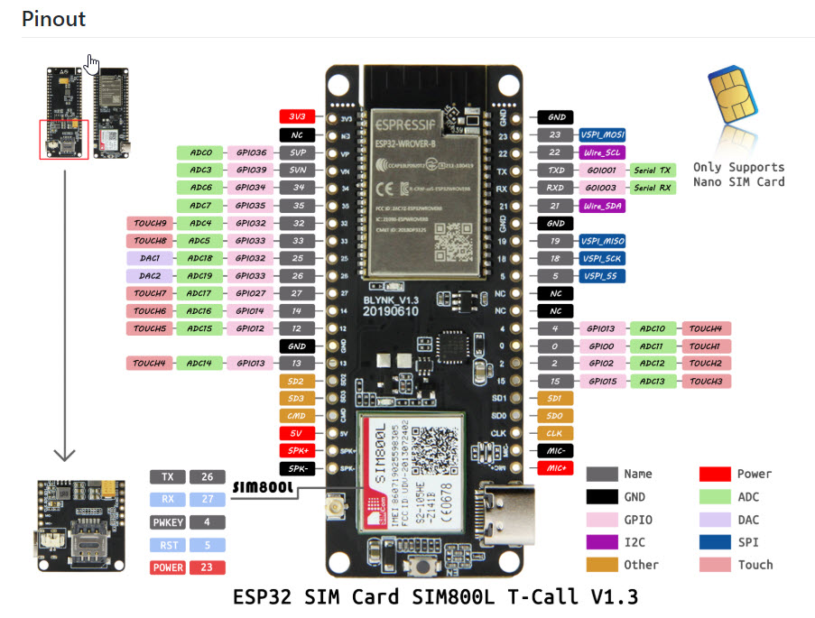

|  |  |
| --- | --- |
| ESP32 | ADXL345 |
| Gnd | Gnd |
| 3.3v | VCC |
| Pin 21 | SDA |
| Pin 22 | SLC |